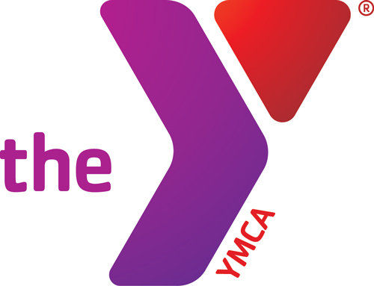
GYM SCHEDULE

March 2016
SUNDAY | MONDAY | TUESDAY | WEDNESDAY | THURSDAY | FRIDAY | SATURDAY
 |  | 1  Noon Ball 12-1:45 | 2  Noon Ball 12-1:45  Freedom Academy 2-3  ;45- | 3  Noon Ball 12-1:45 | 4  Noon Ball 12-1:45 | 5
6 | 7  Noon Ball 12-1:45 | 8  Noon Ball 12-1:45  Whole Gym Closed-Church Challenge Corn Hole 5pm to 9pm | 9  Noon Ball 12-1:45  Freedom Academy 2-3 | 10  Noon Ball 12-1:45 | 11  Noon Ball 12-1:45 | 12  ½ Gym Closed 4-6pm for Birthday Party
13  Whole Gym Closed –Church Challenge Volleyball 1-5pm | 14  Noon Ball 12-1:45  Whole Gym Closed – Church Challenge Volleyball 5 to 9pm (Subject to Change-Only if Needed) | 15  Noon Ball 12-1:45 | 16  Noon Ball 12-1:45  Freedom Academy 2-3  Men’s League 5:45-9 whole gym closed | 17  Noon Ball 12-1:45 | 18  Noon Ball 12-1:45 | 19
20 | 21  Noon Ball 12-1:45 | 22  Noon Ball 12-1:45 | 23  Noon Ball 12-1:45  Freedom Academy 2-3  Men’s League 5:45-9 whole gym closed | 24  Noon Ball 12-1:45 | 25  Noon Ball 12-1:45 | 26
27 | 28  Noon Ball 12-1:45  Walking Track Is Always Open | 29  Noon Ball 12-1:45 | 30  Noon Ball 12-1:45  Freedom Academy 2-3  Men’s League 5:45-9 whole gym closed | 31  Noon Ball 12-1:45

