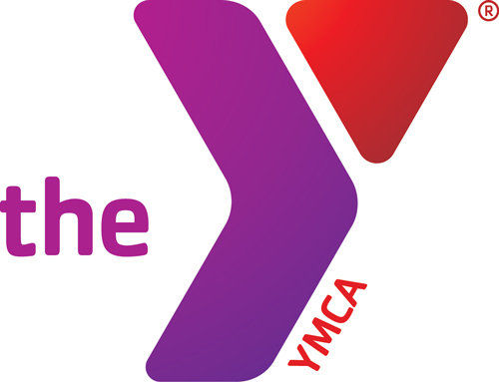
All classes are FREE
to members
---------------------------------
$5 for non-members
GROUP FITNESS SCHEDULE

March 2016

SUNDAY | MONDAY | TUESDAY | WEDNESDAY | THURSDAY | FRIDAY | SATURDAY
 | **Reminder: You must sign up for the Jungle Gym class. Limited spots available.  (6 spots per class) | 1  P90X @ 5:15am  Yoga @ 4:45pm  ZUMBA @ 6:30pm | 2  PiYo @ 5:30am  P90X @ 4:30pm  Jungle Gym @ 6pm  Jungle Gym @ 6:45pm | 3  P90X @ 5:15am  Jungle Gym @ 10am  ZUMBA @ 6:30pm | 4  P90X @ 4:30pm  Yoga @ 4:45pm  Yoga @ 6:30pm | 5  P90X @ 8am  Yoga @ 9am  ZUMBA @ 10am
6 | 7  SBR Boot Camp @ 5:30am  Yoga @ 9am  Zumba @ 10 am  P90X @ 4:30pm  Yoga @ 6:30pm  ZUMBA @ 6:30pm | 8  Yoga @ 4:45pm  SBR Boot Camp @ 9am  ZUMBA @ 6:30pm | 9  SBR Boot Camp @ 5:30am  SBR Boot Camp @ 9am  P90X @ 4:30pm  Jungle Gym @ 6pm Jungle Gym @ 6:45pm | 10  P90X @ 5:15am  SBR Boot Camp @ 9am  Jungle Gym @ 10am  ZUMBA @ 6:30pm | 11  SBR Boot Camp @ 5:30am  P90X @ 4:30pm  Yoga @ 4:45pm  Yoga @ 6:30pm | 12  P90X @ 8am  Yoga @ 9am  ZUMBA @ 10am
13 | 14  SBR Boot Camp @ 5:30am  Yoga @ 9am  Zumba @ 10 am  P90X @ 4:30pm  Yoga @ 6:30pm  ZUMBA @ 6:30pm | 15  P90X @ 5:15am  SBR Boot Camp @ 9am  Yoga @ 4:45pm  ZUMBA @ 6:30pm | 16  SBR Boot Camp @ 5:30am  SBR Boot Camp @ 9am  P90X @ 4:30pm  Jungle Gym @ 6pm Jungle Gym @ 6:45pm | 17  P90X @ 5:15am SBR Boot Camp @ 9am  Jungle Gym @5pm  Jungle Gym @ 5:45pm  ZUMBA @ 6:30pm | 18  SBR Boot Camp @ 5:30am  P90X @ 4:30pm  Yoga @ 4:45pm  Yoga @ 6:30pm | 19  P90X @ 8am  Yoga @ 9am  ZUMBA @ 10am
20 | 21  Yoga @ 9am  Zumba @ 10 am  P90X @ 4:30pm  Yoga @ 6:30pm  ZUMBA @ 6:30pm | 22  P90X @ 5:15am  Yoga @ 4:45pm  ZUMBA @ 6:30pm | 23  P90X @ 4:30pm  Jungle Gym @ 6pm Jungle Gym @ 6:45pm | 24  P90X @ 5:15am  Jungle Gym @5pm Jungle Gym @ 5:45pm  ZUMBA @ 6:30pm | 25  Y Closed – Good Friday | 26  P90X @ 8am  Yoga @ 9am  ZUMBA @ 10am
27 | 28  Insanity @ 5:30am  Yoga @ 9am  Zumba @ 10 am  P90X @ 4:30pm  Yoga @ 6:30pm  ZUMBA @ 6:30pm | 29  P90X @ 5:15am  Yoga @ 4:45pm  ZUMBA @ 6:30pm | 30  PiYo @ 5:30am  P90X @ 4:30pm  Jungle Gym @ 6pm Jungle Gym @ 6:45pm  INSTRUCTORS  GWEN – ZUMBA/Yoga SARA – Yoga KATHY – ZUMBA  JACKIE – Insanity/PiYo/SBR Boot Camp Karinsa – P90X SHELLEY –ZUMBA Evan – Jungle Gym | 31  P90X @ 5:15am  Jungle Gym @5pm Jungle Gym @ 5:45pm  ZUMBA @ 6:30pm
Child Watch is available M-Th. 5:30pm-7:45pm for 6mth-9yr olds.
FREE for members
$5/child for non-members

