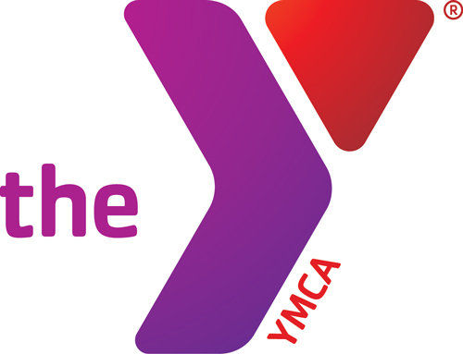
GROUP FITNESS SCHEDULE

November 2015

SUNDAY | MONDAY | TUESDAY | WEDNESDAY | THURSDAY | FRIDAY |  | SATURDAY
1 | 2  Insanity @ 5:30am  Yoga @ 9am  Zumba @ 10 am  P90X @ 4:30pm  Yoga @ 6:30pm  ZUMBA @ 6:30pm | 3  Cardio Power @ 9am  Yoga @ 4:45pm  ZUMBA @ 6:30pm | 4  PiYo @ 5:30am  P90X @ 4:30pm | 5  ZUMBA @ 6:30pm |  | 6  P90X @ 4:30pm  Yoga @ 4:45pm  Yoga @ 6:30pm | 7  P90X @ 8am  Yoga @ 9am
8 | 9  Insanity @ 5:30am  Yoga @ 9am  Zumba @ 10 am  P90X @ 4:30pm  Yoga @ 6:30pm  ZUMBA @ 6:30pm | 10  P90X @ 5:15am Cardio Power @ 9am  Yoga @ 4:45pm  ZUMBA @ 6:30pm | 11  PiYo @ 5:30am  P90X @ 4:30pm | 12  P90X @ 5:15am  ZUMBA @ 6:30pm |  | 13  P90X @ 4:30pm  Yoga @ 4:45pm  Yoga @ 6:30pm | 14  P90X @ 8am  Yoga @ 9am
15 | 16  Insanity @ 5:30am  Yoga @ 9am  Zumba @ 10 am  P90X @ 4:30pm  Yoga @ 6:30pm  ZUMBA @ 6:30pm | 17  P90X @ 5:15am Cardio Power @ 9am  Yoga @ 4:45pm  ZUMBA @ 6:30pm | 18  PiYo @ 5:30am  P90X @ 4:30pm | 19  P90X @ 5:15am  ZUMBA @ 6:30pm |  | 20  P90X @ 4:30pm  Yoga @ 4:45pm  Yoga @ 6:30pm | 21  P90X @ 8am  Yoga @ 9am
22 | 23  Insanity @ 5:30am  Yoga @ 9am  Zumba @ 10 am  P90X @ 4:30pm  Yoga @ 6:30pm  ZUMBA @ 6:30pm | 24  P90X @ 5:15am  Cardio Power @ 9am  Yoga @ 4:45pm  ZUMBA @ 6:30pm | 25  P90X @ 4:30pm | 26  Y CLOSED –THANKSGIVING DAY |  | 27  P90X @ 4:30pm  Yoga @ 4:45pm  Yoga @ 6:30pm | 28  P90X @ 8am  Yoga @ 9am
29 | 30  Insanity @ 5:30am  Yoga @ 9am  Zumba @ 10 am  P90X @ 4:30pm  Yoga @ 6:30pm  ZUMBA @ 6:30pm |  | INSTRUCTORS  GWEN – ZUMBA/yoga SARA - yoga  JACKIE – Insanity/PiYo/Cardio Power  KATHY – ZUMBA - Jungle Gym Class  Karinsa – P90X | **Jungle Gym will return in December!**
All classes are FREE
to members
---------------------------------
$5 for non-members
Child Watch is available M-Th. 5:30pm-7:45pm for 6mth-9yr olds.
FREE for members
$5/child for non-members

